# CS 340 README Template

*Use this template to complete your README file. When completing the template, keep the headings as they are so that your document has a clear organization. Remove the italicized prompt text after you have completed each section for a polished final document.*

## About the Project/Project Title

This project implements a dashboard to view and manipulate data for Grazioso Salvare using databases created by several animal shelters in the Austin, Texas area. This project utilizes the MongoDB structure, driven by a created CRUD module in Python used by a locally hosted, web-based dashboard. This project includes features to analyze and manipulate data such as filters, data point mapping, and data modelling.

## Motivation

This project was started by Grazioso Salvare, a company committed to identifying dogs suitable for search-and-rescue training. This project happened in coordination with several non-profit animal shelters in the Austin, Texas area. The purpose of this project was to utilize databases provided by these shelters to create a dashboard that included several data manipulation tools. Grazioso Salvare wanted a way to filter the database based on criteria for the following search and rescue cases: water rescue, mountain/wilderness rescue, and disaster rescue/individual tracking. Additionally, the data table includes selectable rows to show the location of each animal on a map and a graph showing the breakdown of each animal by breed. This allows for easy, usable access to the shelter’s database and allows for productive, and efficient animal identification and acquisition.

## Getting Started

The first thing that is needed for this project is the .csv file that this data is based on. This data is then added to the MongoDB database using the MongoShell and a created user login. Next, the animalShelter.py file must be downloaded and placed in the same directory as the ProjectTwoDashboard.ipynb file so that the dashboard can access the crud module. Next, the ProjectTwoDashboard.ipynb file must be opened in the Jupyter Notebook environment. From here, press run and click the local host link to access the dashboard. Installation procedures for each external resource is explained in the next section.

## Installation

There are several pieces of software that are utilized in this project, they will be listed with their usage justification and steps to acquire the software below:

* **MongoDB:** This is the database framework utilized in this project. This framework was chosen due to the flexibility of schemas for MongoDB databases, the easy scaling potential, and the functionality of Python Scripts in conjunction with the database. MongoDB can be installed online for several platforms such as Linux, Windows, and Mac. The link to the download MongoDB is: https://www.mongodb.com/try/download/community
* **Spyder IDE:** This is the integrated development environment used to create the CRUD module which drives the web-based application. This IDE is great for data analysis scripting and is a great choice for this scenario. The link to download Spyder is: <https://www.spyder-ide.org/>
* **Python 3.9.12:** This is the version of Python utilized in this project. The Python language is used to create the CRUD module and the construction of the dashboard. The link to install Python is: <https://www.python.org/downloads/release/python-3912/>
* **Jupyter Notebook:** Jupyter notebooks are used to create the dashboard and its attributes. It is another Pythond IDE but allows for web-based applications to be hosted from it. Jupyter Notebook can be installed using the following code block in a Python script:

pip install notebook

* **Dash Framework:** The Dash Framework is the framework used to control, create, and host the dashboard. This framework allows for a combination of html code to create the dashboard and Python code to create the logic of the dashboard. The Dash Framework can be installed from the following code block in a Python script:

from dash import Dash

## Usage

**Accessing the Dashboard**

To access the dashboard first press the run button then click the local host link. Screenshots of this is shown below:

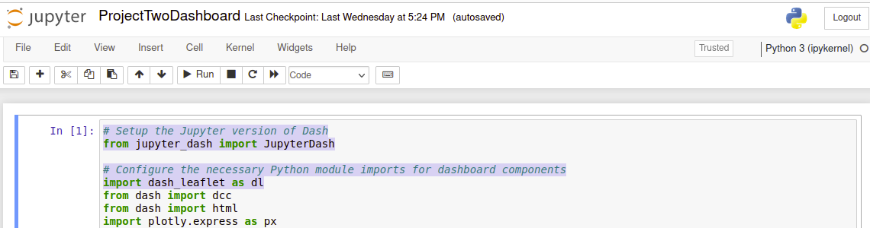

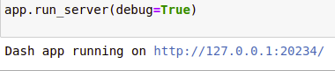

After clicking this link, you should be connected to the dashboard. It should look like the following screenshot:

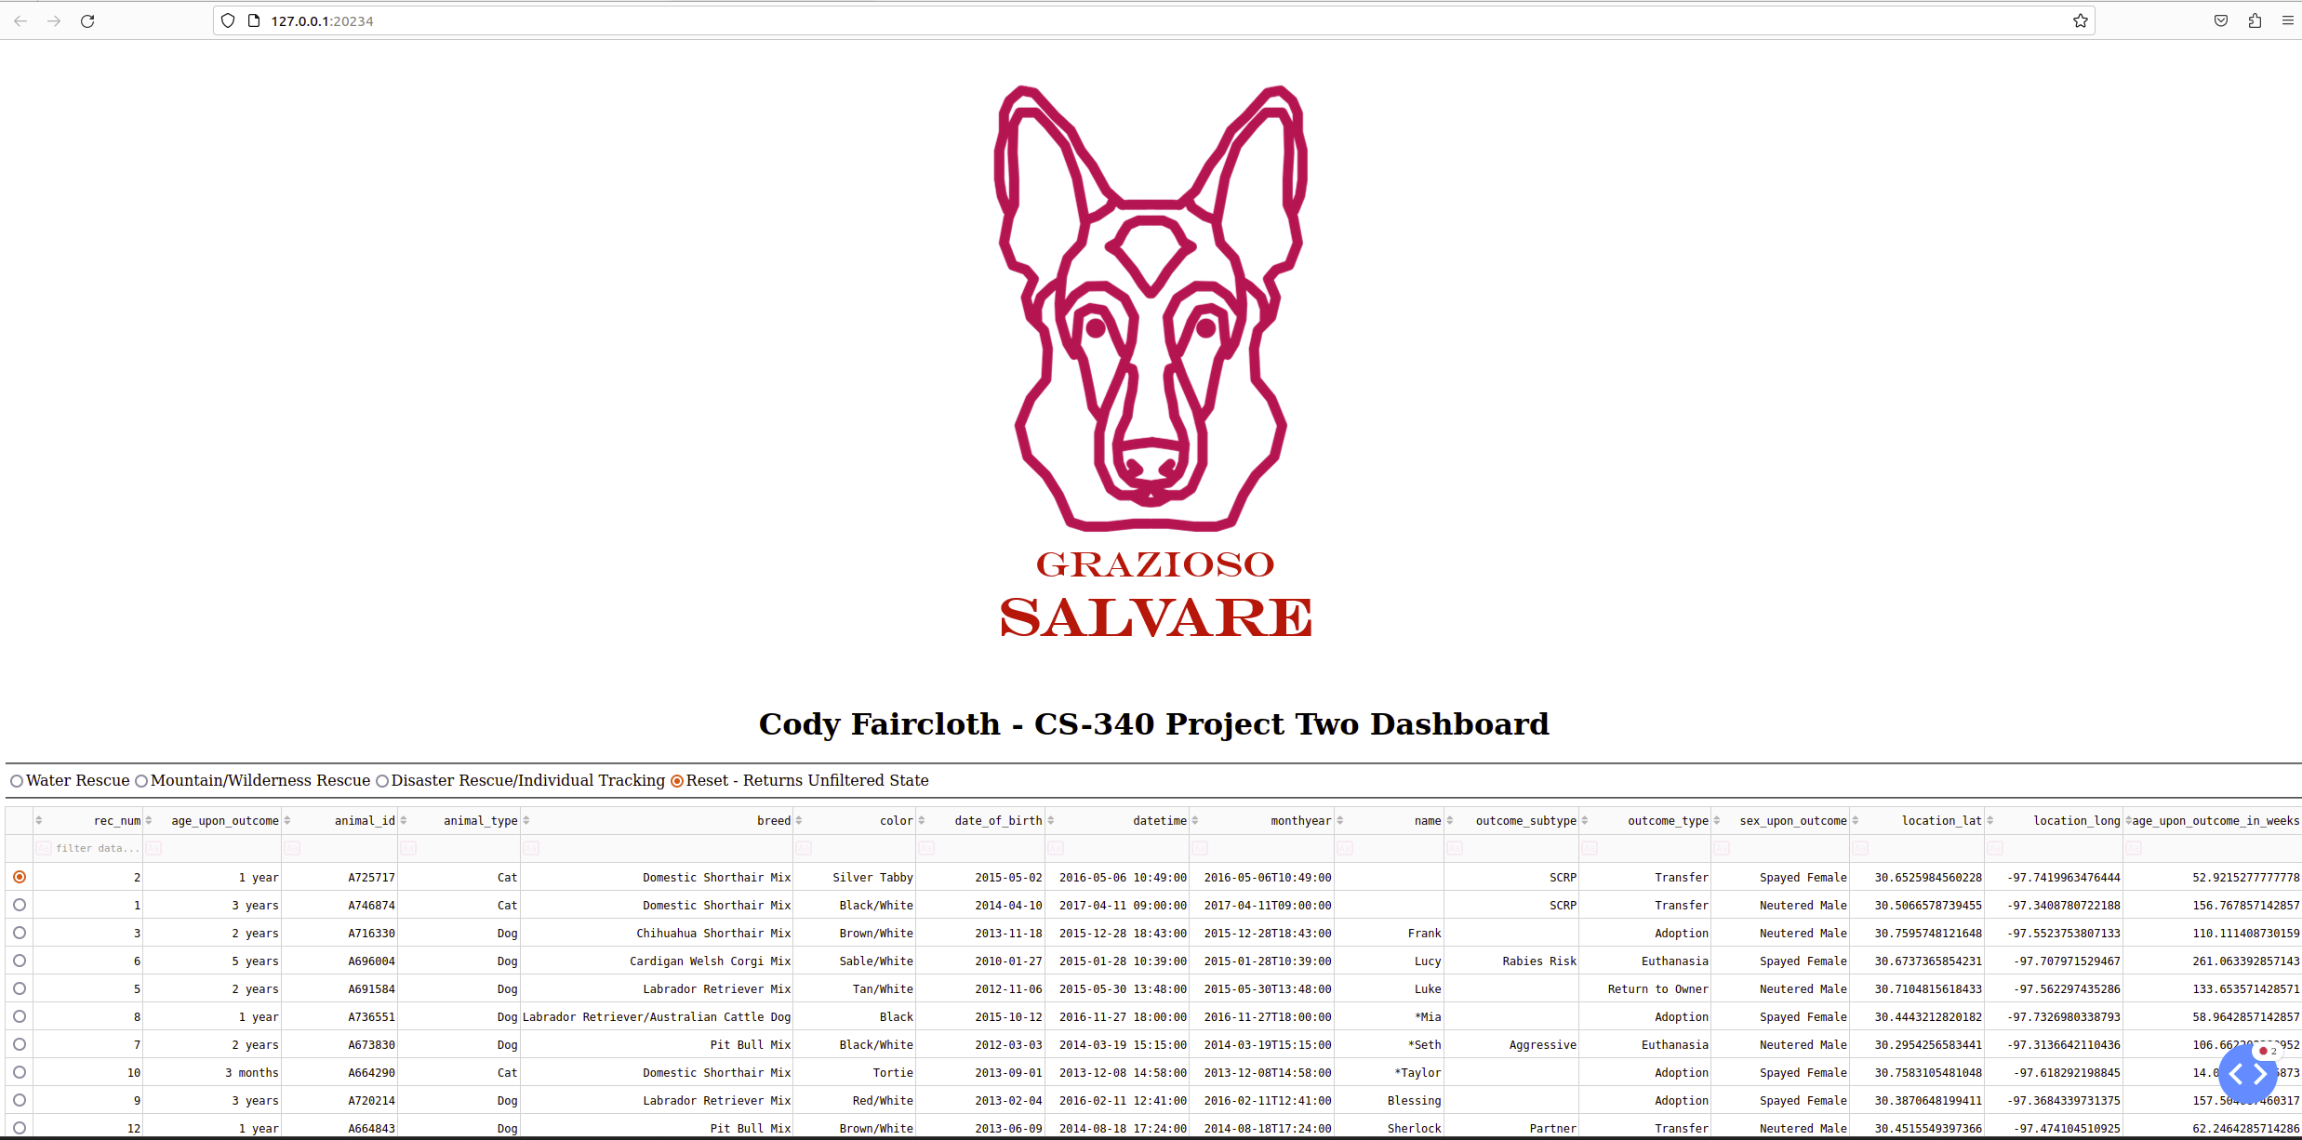

**Data Filters**

This dashboard includes a data filter feature that returns different data frames based on the filters. To select a different data frame, simply click the corresponding button to the filter you would like to select. Currently, there are filters for water rescue, mountain/wilderness rescue, disaster rescue/individual tracking, and a filter to reset the data frame to the full database. Screenshots of each filter is shown below:

Full Database:

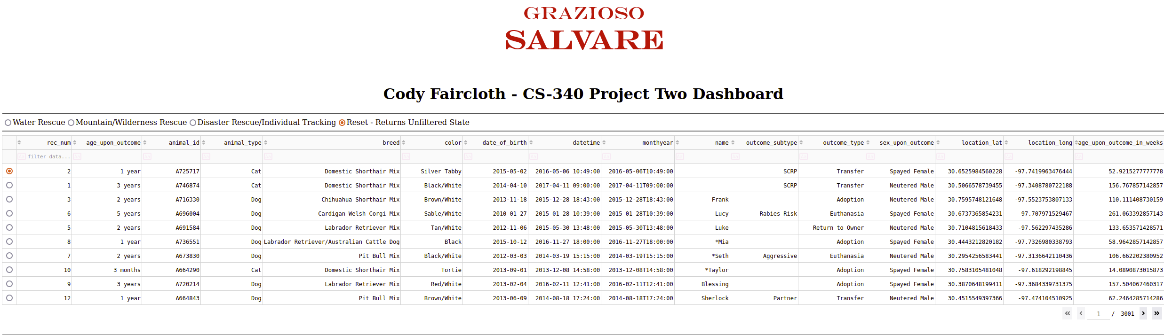

Water Rescue:

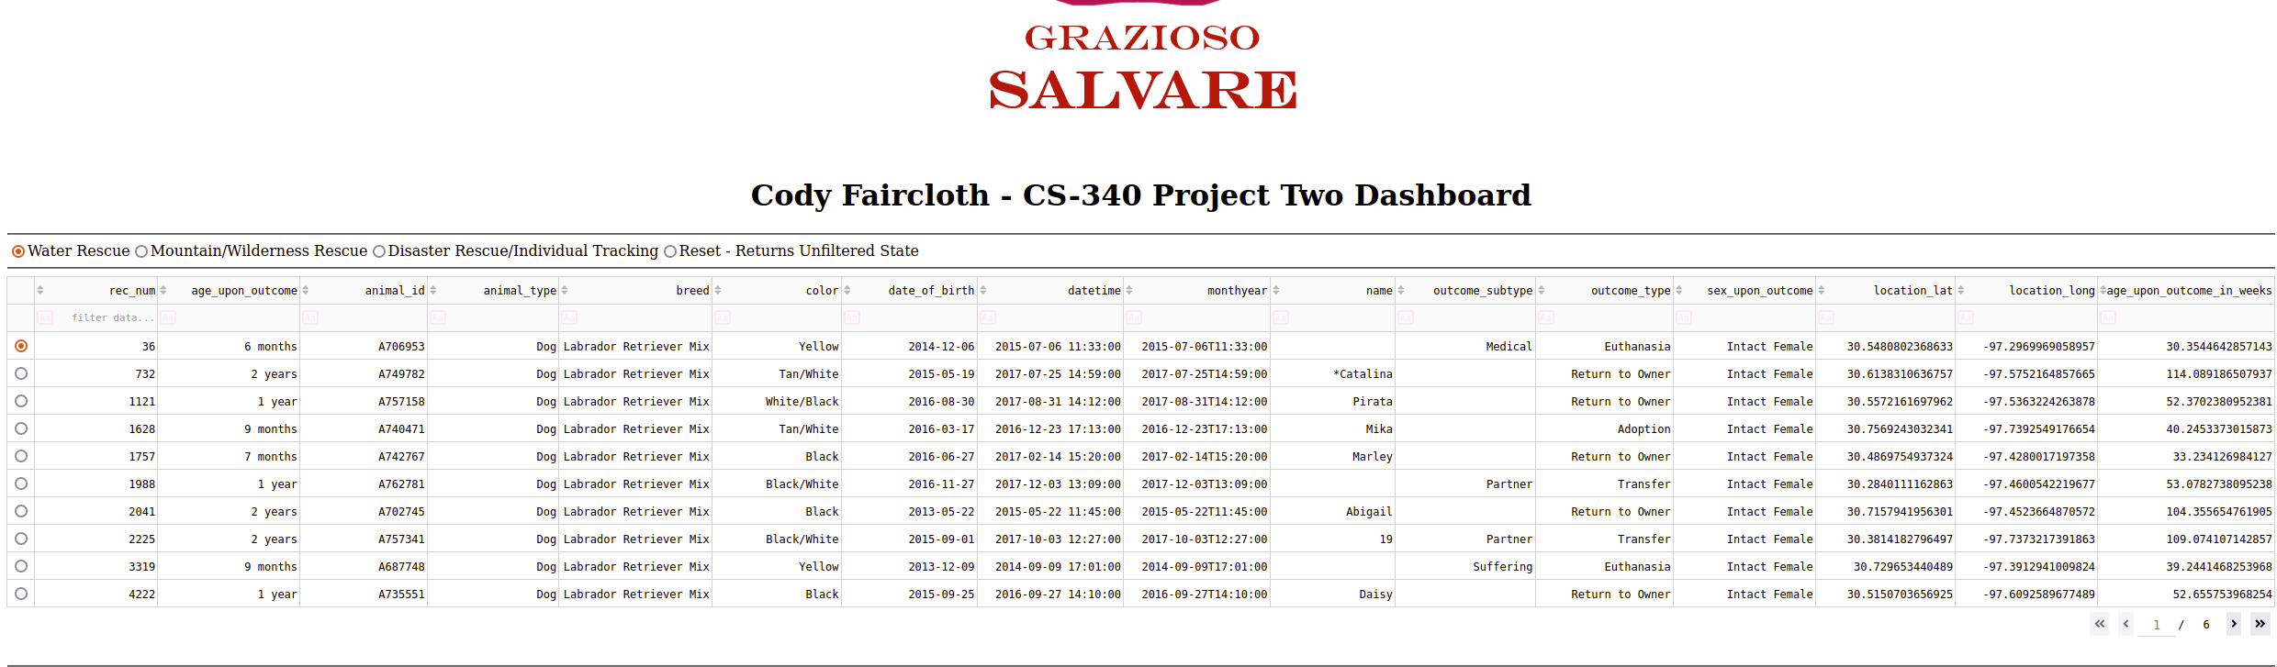

Mountain/Wilderness Rescue:

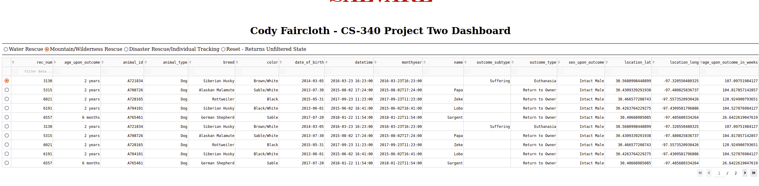

Disaster Rescue/Individual Tracking:

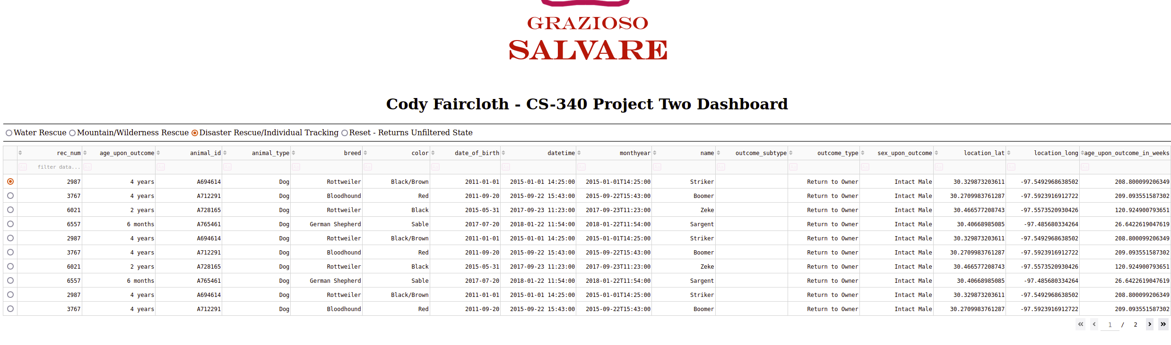

**Data Graphing**

This dashboard also features a pie graph showing the breakdown of animals by breed for each selected data frame. This graph is dependent on the selected filters shown above. When a filter is selected the graph will update according to the selected data frame. The graph can be changed by simply selecting a filter as explained in the previous section. Screenshots of the filters and graph changes are shown below:

Full Database:

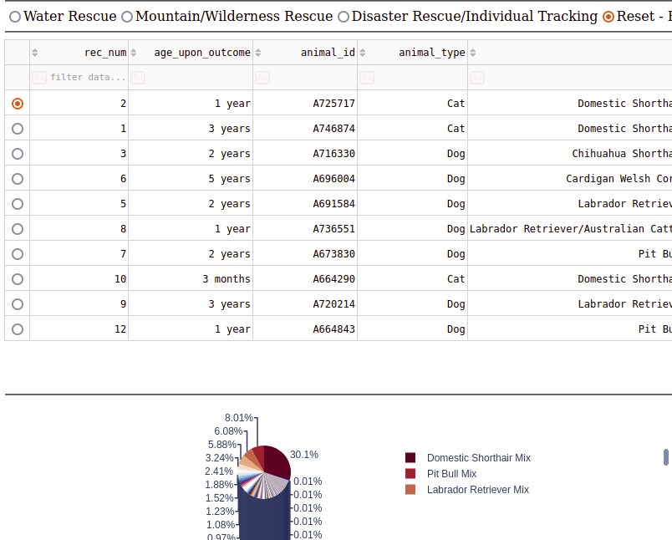

Water Rescue:

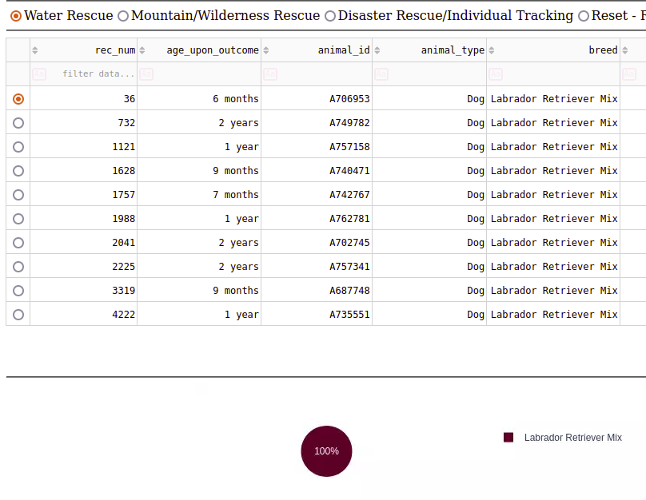

Mountain/Wilderness Rescue:

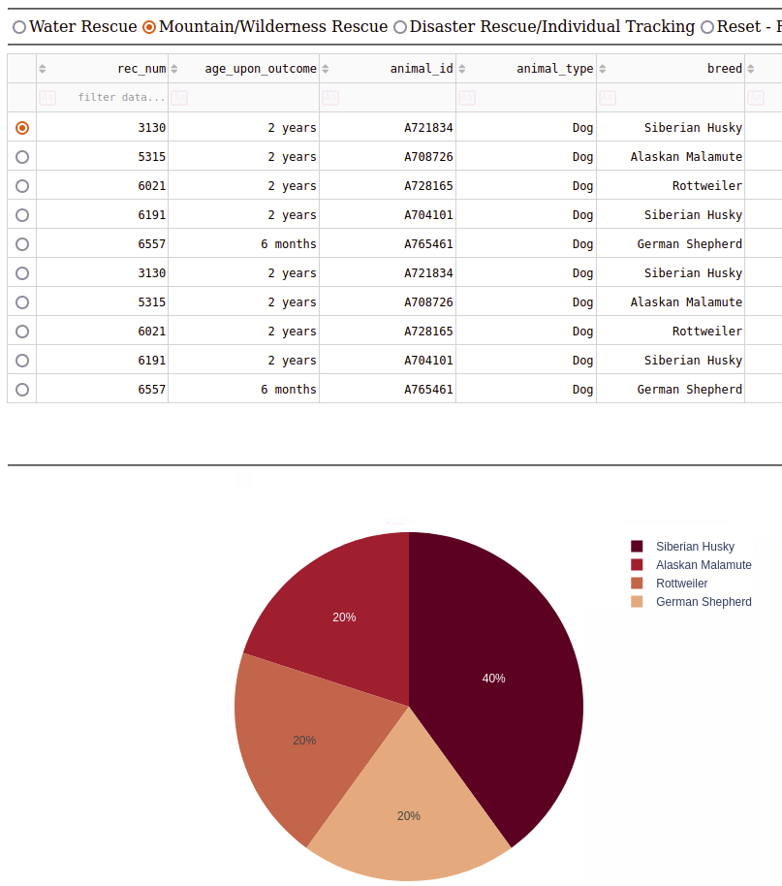

Disaster Rescue/Individual Tracking:

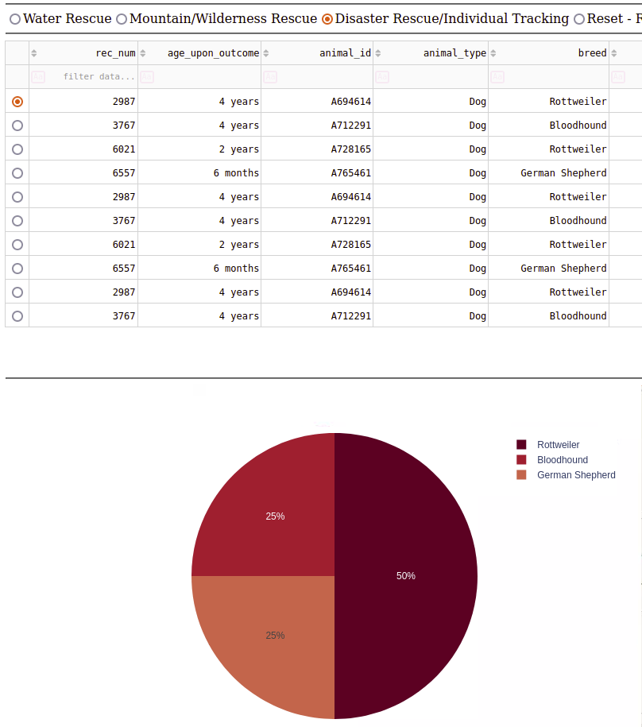

**Data Point Map**

This dashboard also includes a geographic mapping feature which maps a data point on a local map of Austin, Texas depending on the coordinates set in the database. The map will display the first row of the table by default as shown in the screenshot below:

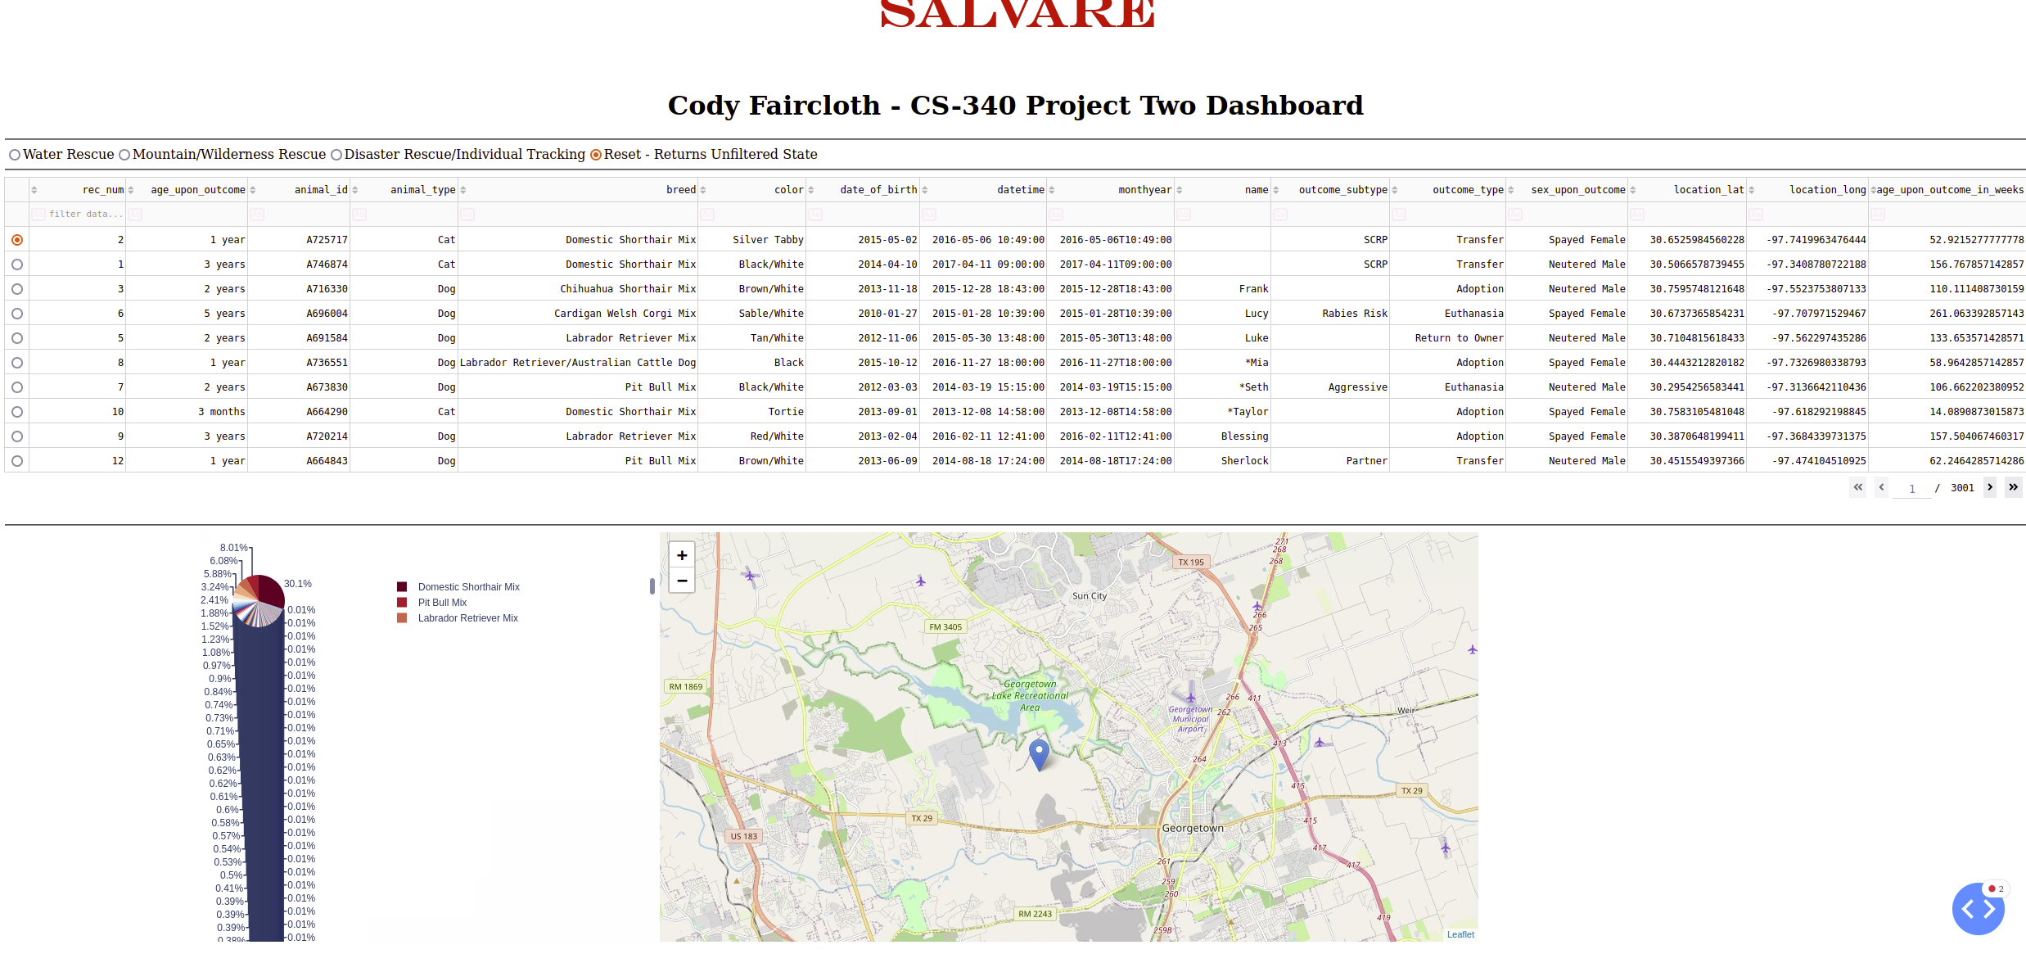

To view the location of a different animal, simply click the button next to the animal you would like to view. This will update the map and display a point indicating where the animal is located. An example of this using the Water Rescue filter and the fourth animal on the list, Marley, is shown in the screenshot below:

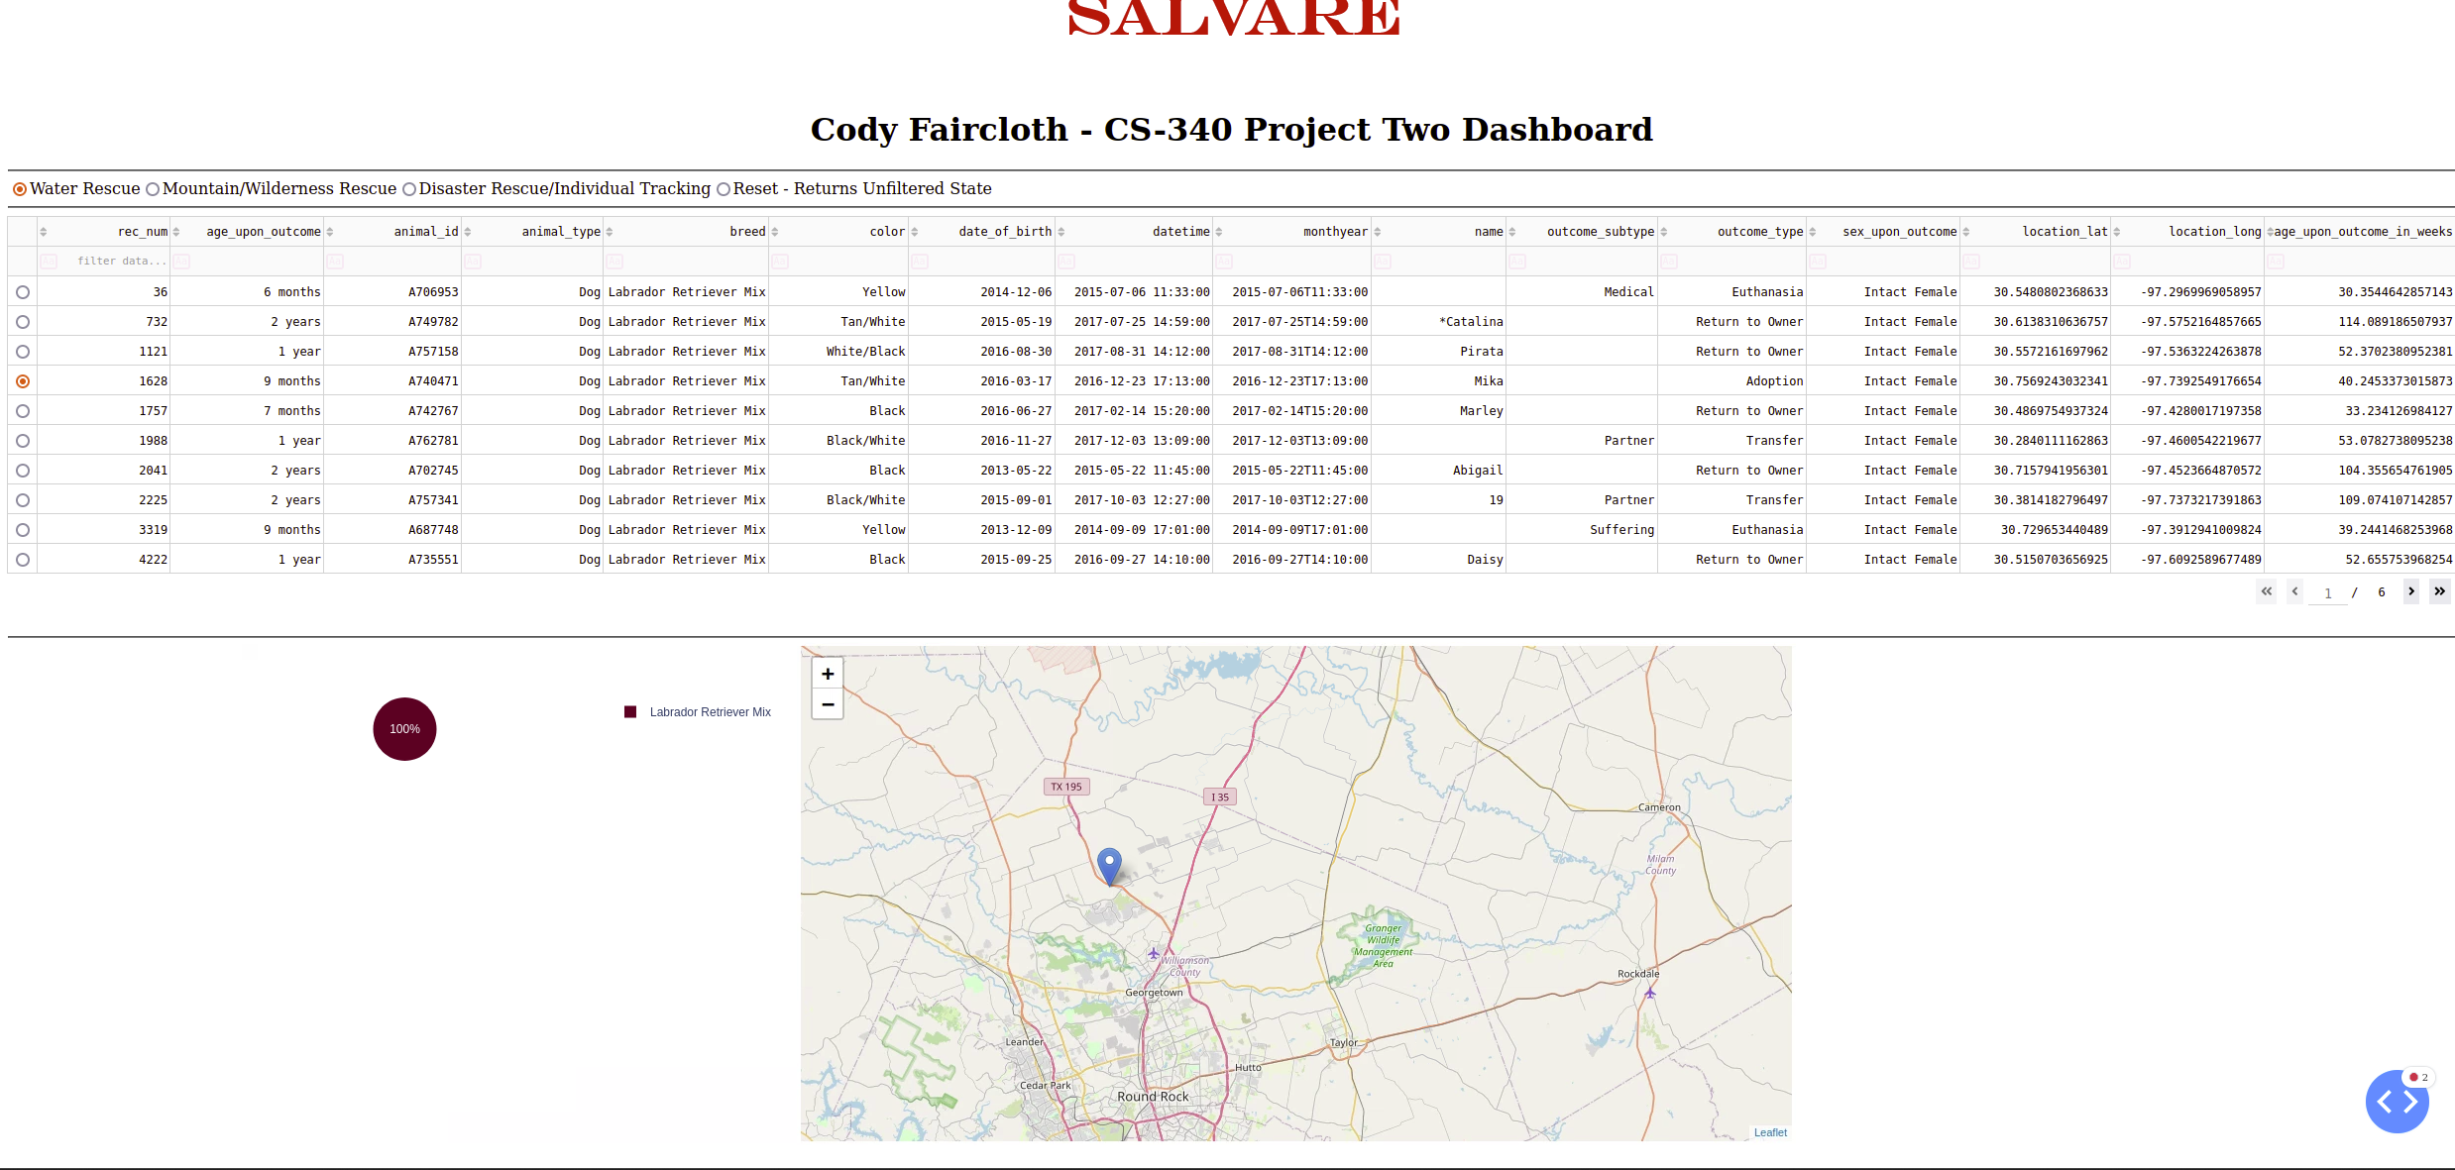

## Contact

Your name: Cody Faircloth – cody.faircloth@snhu.edu